Structural Reflexology® Portsmouth, NH

Instructed by Geraldine Villeneuve
April 21 & 22, 2024

Location: Strawberry Banke Museum
14 Hancock Street,
Portsmouth, NH

Time: Sunday and Monday @ 8:30am to 5:30pm
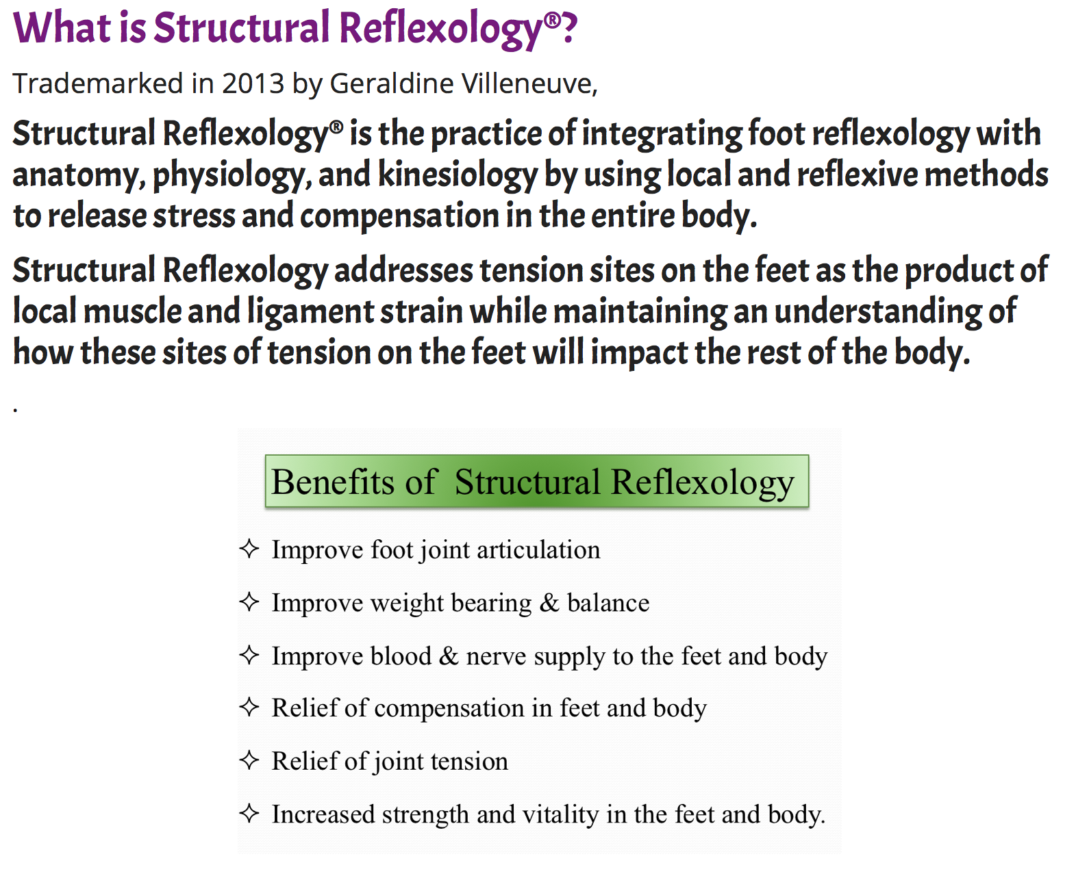

Registration:

Name of Student: _ ____________________
Address:____________________________
City:_______________________________
State:______________________________
Country:____________________________
Postal Code:_____________

Phone:____/____/_____
Email:______________________________

Profession:__________________________

Professional Membership(s)______________
_
_____________________________

Course Tuition is $520.00USD/$495.00 Early
Learning Objectives:
- Definition, purpose, and benefits of Structural Reflexology®.
- Identify bones and columns of the foot.
- Understand how feet support and move the body.
- Understand bodily reactions to joint tension in feet.
- Associate foot structure and function with reflex activity.

- Identify muscles that move the foot and their reflexive value.
- Learn three measurements of the foot.
- Ink Press reading.
- Structural Reflexology &
passive foot mobilization sequence



bird if paid by Feb 1, 2024

Payments by check may be addressed to:
Structural Reflexology, LLC
Mailed to 27 Saxon Hill Road, Essex, Vermont
05452

Or pay through Venmo:
https://venmo.com/u/Geraldine-Villeneuve

Geraldine Villeneuve
BS, LMP, ABCR,
Structural Reflexology® Practitioner
www.PutYourBestFeetForward.com
structuralreflexology@gmail.com

Geraldine is the acclaimed Author of
Put Your Best Feet Forward and coming this December!
Free-Range Feet

***Please print registration form
and return via email or postal mail.

Continuing Education units available
